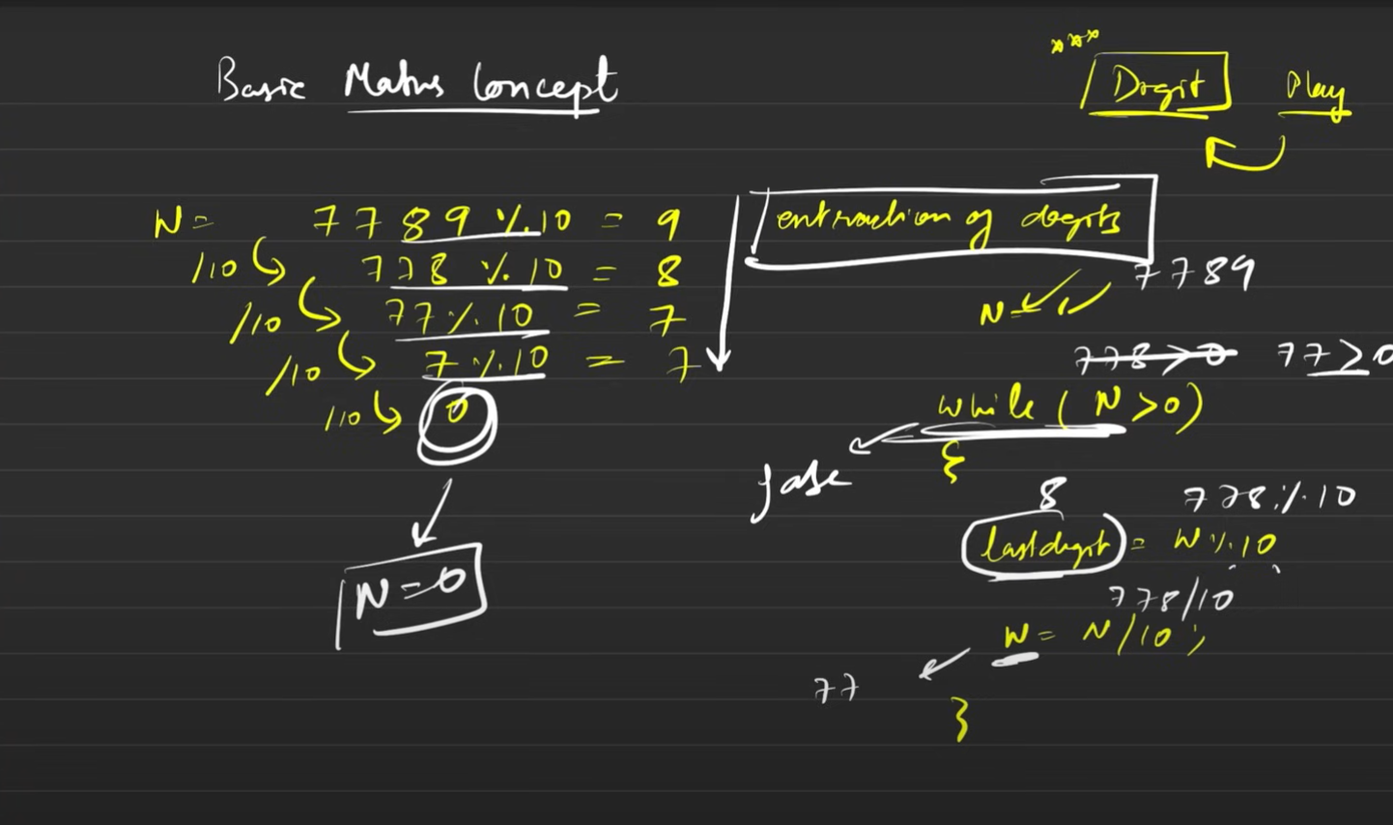

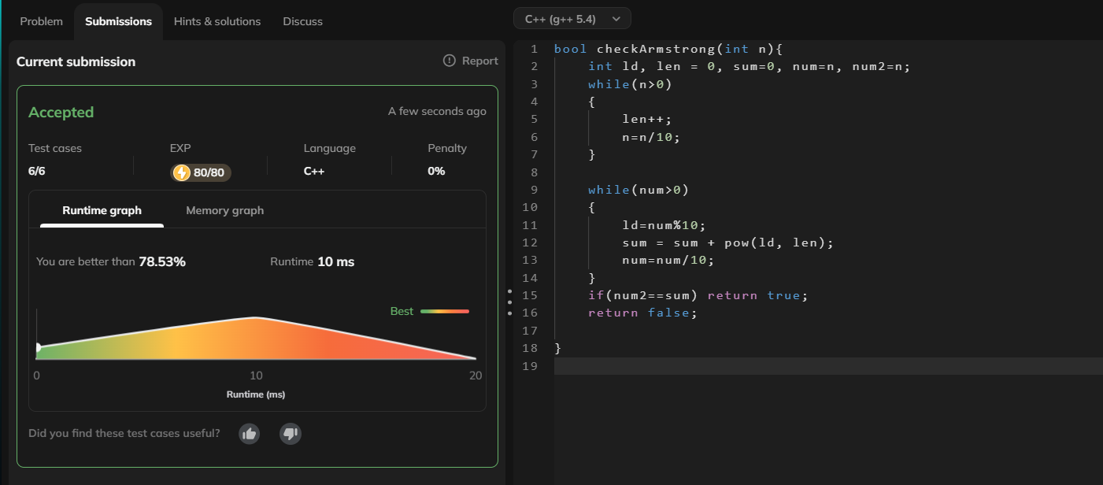//armstrong solution (as premium leetcode problem was not accessible)

//printing the factors //refer notebook to understand the logic //One of the most imp codes ever

//caution: Must do it again on a compiler for storing the optimised approach

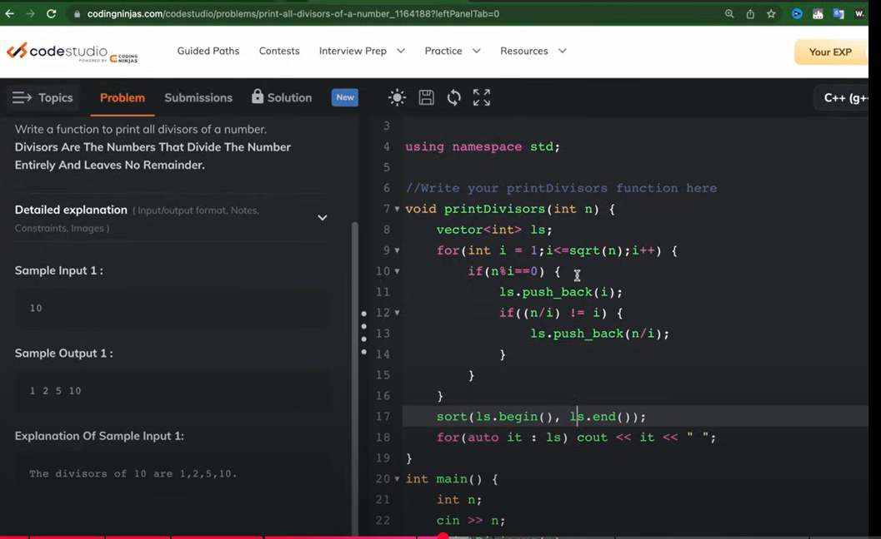

However in this code the we can see that the sqrt() func is called every time and hence it itself takes time in calling the sqrt() func. Below given is the more optimized version of this code.

We have also used vectors to store the factors and sort and print them.  
  
Internal sorting takes O(nlogn)

Printing takes takes O(n)

And i\*i<=n works same as i<=sqrt(n) but its better since we don’t need to call a func for it which saves time. (If you observe we have just shifted the sqrt to LHS as square as we do in maths.

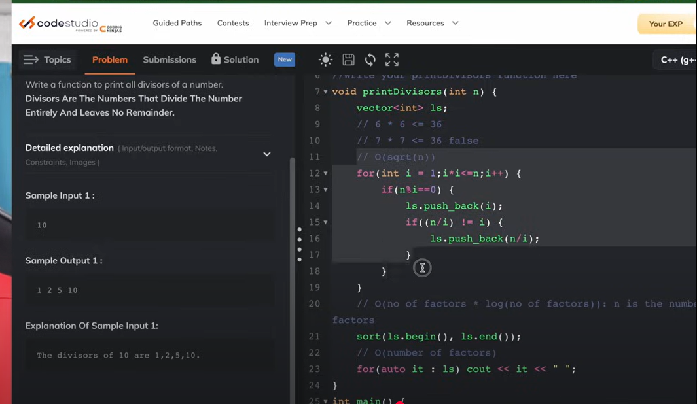

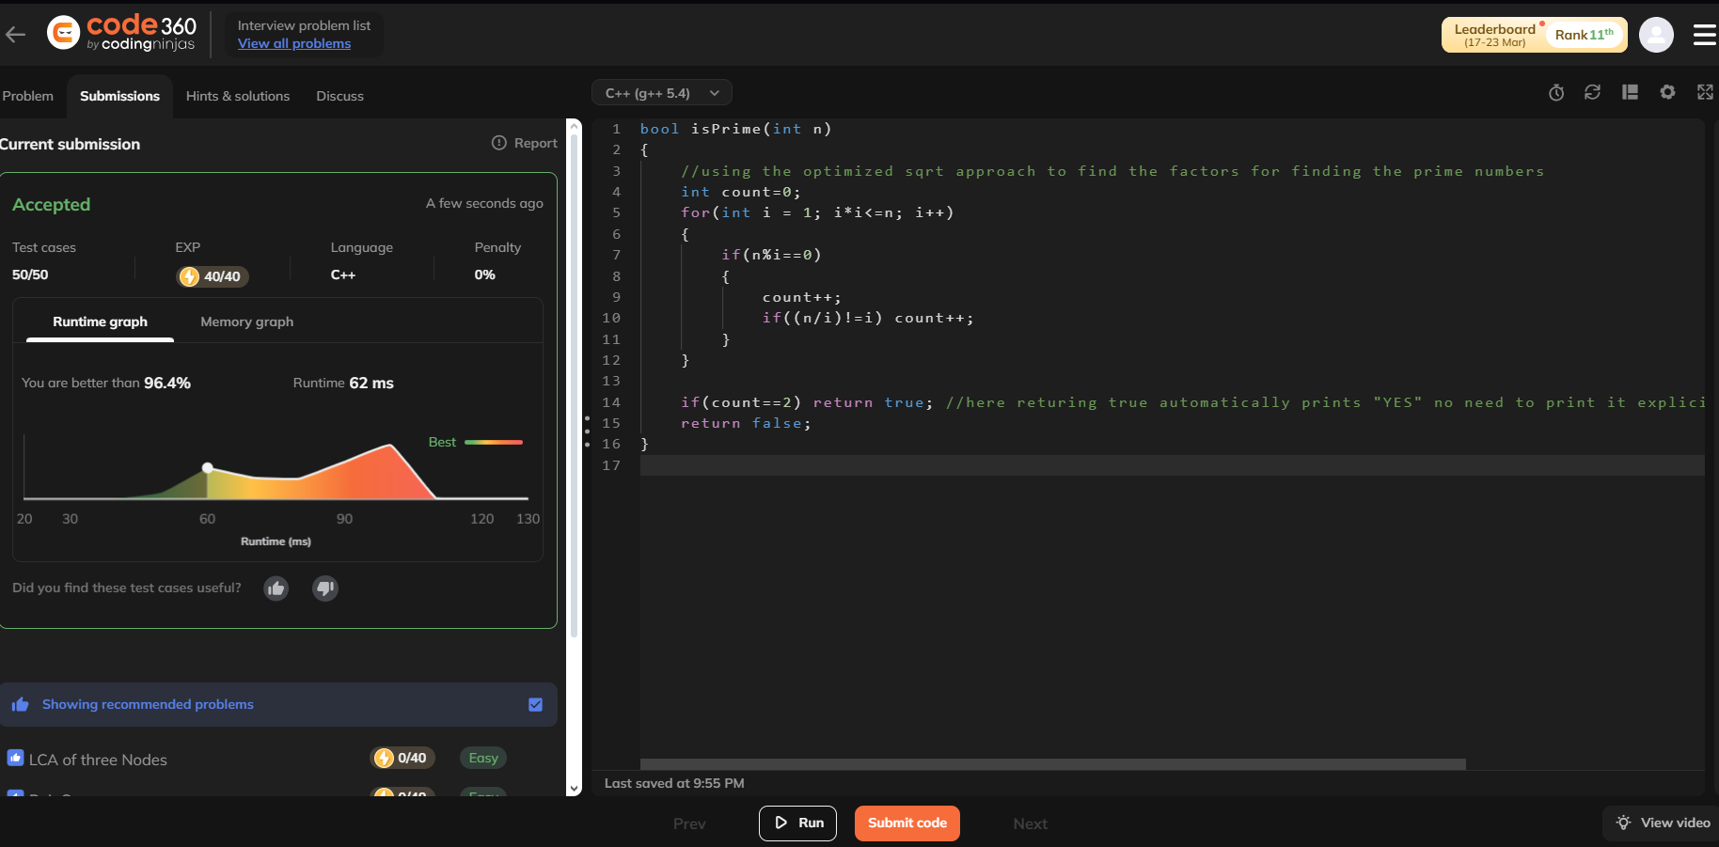//prime numbers